Creating a custom part in Eagle

To create your custom part in Eagle is very simple, although to the uninitiated it can be quite confusing.

The first item you will need for your custom part will be its datasheet. In this example, we will be using the LM324 Quad Op Amp from ON Semiconductor, its datasheet is located here: <https://www.onsemi.com/pub/Collateral/LM324-D.PDF>

In the datasheet, you will need a few things, the pin designation map, which in the case of the LM324 is located on page 1 in the pin connections diagram. You will also need to know the package type you are wanting to implement, these can also be found in the datasheet, in this instance on page 11. Looking at the three choices, we will start with the TSSOP-14 package to save space on out finished circuit board.

Start Eagle, and from the Control Panel, select File > New > Library  
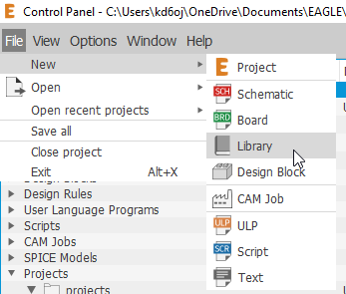

You should now see a blank library screen:

